A000-MEX-Mezcala, Guerrero-**Maskette-Anthropomorphic-Brown Serpentine-**Early Preclassic-700-200 BCE

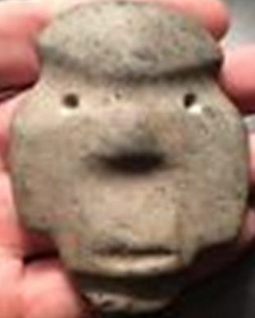

**Fig. 1.** Mezcala, Guerrero-**Maskette-Anthropomorphic-Brown Serpentine-**Early Preclassic-700-200 BCE

**Case no.:**

**Accession Number:**

**Formal Label:** Mezcala, Guerrero-**Maskette-Anthropomorphic-Brown Serpentine-**Early Preclassic-700-200 BCE

**Display Description:**

This brown serpentine Mezcala anthropomorphic maskette is in the formalistic style that places it in the Early Preclassic Period, 700-200 BCE.

The Mezcala style was named by Miguel Covarrubias (1904-1957) who arranged small objects of polished stone, peculiar to the State of Guerrero in the form of figurines and masks, animal effigies and ornaments such as pearls, pendants or earrings (Covarrubias 1948, 1956, 1966: 106) into of five major groups of which the Mezcala figurine style was Type 5.

Type 1: Olmec or La Venta style (Chontal) Objects

Type 2: Olmec Style Objects

Type 3: Teotihuacan Style Objects

Type 4: Olmec-Teotihuacan Objects

Type 5: Local Style Objects-Mezcala, schematized pieces

The function of these figurines is hypothesized to be 1) tribute to fertility deities, 2) tribute to ancestors, and 3) consecration of habitations. These objects are grooved using what appears to have been an ax, with cuts and planes arranged geometrically and with facial or bodily features scarcely suggested. The raw material used is generally a hard stone (diorite, serpentine, andesite, marble and obsidian) the color of which varies from green to gray-green or gray. The Mezcala style is not limited to anthropomorphic representations but includes jaguars, frogs, monkeys, squirrels, birds, which are personified forces of nature. In addition are miniature Mezcala façades of temples, Mezcala stone implements (such as projectile points, palettes and axes) and Mezcala ornaments (such as beads and cylinders).

**LC Classification**:  [F1219.1.G93](http://luna.wellesley.edu/search~S1?/mF1219.1.G93+G29+1992/mf++1219.1+g93+g29+1992/-3,-1,,B/browse)

**Date or Time Horizon:** Early Preclassic, 700-200 BCE

**Geographical Area:** Balsas, Guerrero, Mexico

**Map:**



Fig. 2. Map of Guerrero, Mezcala, after <http://www.samildan-art.com>.



Fig. 2. Map of Coastal Guerrero, Mezcala, after <https://4.bp.blogspot.com>.

**GPS coordinates**: Balsas, Mezcala: 17° 55' 00" N, 102° 10' 00" W

**Cultural Affiliation:** Mezcala

**Medium:** serpentine

**Dimensions:**

**Weight:**

**Condition: original**

**Provenance:**

**Discussion:**

The definition of the Mezcala styles has been diverse. For instance, Carlo Gay (1967) restricted the Mezcala style to schematic objects dating them to the Preclassic Period. Serra (1973) on the other hand, established another classification focused on anthropomorphic representations.

In addition, Re-appropriated Mezcala votive objects have been identified at:

1. Teotihuacan (Rubín de la Borbolla 1964)
2. Xochicalco Valley (Noguera 1961; Sáenz 1961, 1963).

A Mezcala anthropomorphic figurine was identified near Xochicalco in association with Tlahuica Polychrome pottery, giving it a date of the Postclassic. Several figurines of the Olmec and Teotihuacan groups of Covarrubias were found in funeral offerings dated from the Classic Period.

1. The great pyramid of Tenochtitlan, Templo Mayor.

This was in the heart of the capital of the Aztecs. Although Templo Mayor was destroyed in the 16th century by the Spaniards to make way for massive Christianization of the local populace, Manuel Gamio rediscovered the southwest corner of the pyramid in 1913. Then on 21st February 1978 workers uncovered a 3.1 m stone disc of the Aztec Coyolxauhqui goddess of Darkness.

This discovery re-invigorated excavations of the Templo Mayor. These excavations have uncovered many Mezcala figurines that have established it as a repository of Mezcala and other figurines re-appropriated by the Aztecs in their rituals (Batres 1902; Angulo 1966; Contreras 1979; Gonzalez 1986, 1987). Angulo and Contreras in the 1960s described an offering in the structures of the Templo Mayor which contained, among other things, five figurines and five anthropomorphic masks of Chontal style (type 1 of Covarrubias), two masks of type 3 and a small temple model. This offering corresponded to stage IV or the Postclassic Period. Gonzalez described thirteen Mezcala offerings in 1978-1980, which were directly associated with the structure of the Templo Mayor. A total of 321 anthropomorphic hard stone figurines were excavated of which

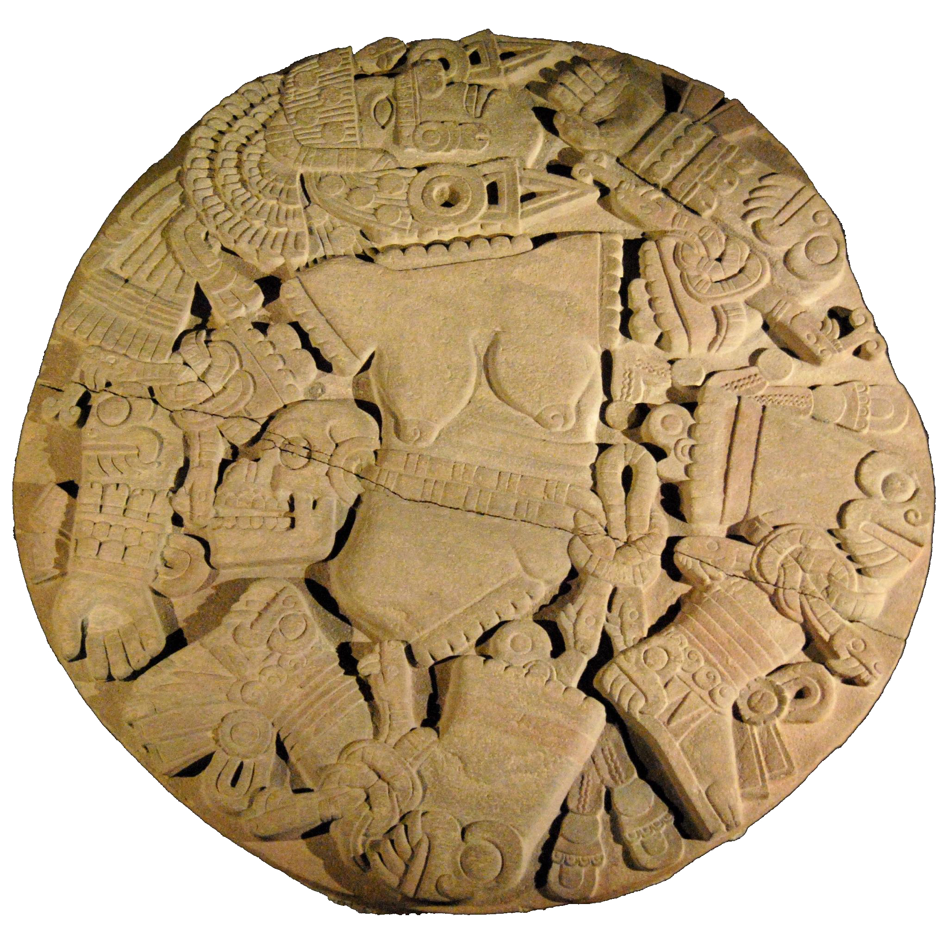

Fig. 3.  3.1 m stone disc of the Aztec Coyolxauhqui (Goddess of Darkness) after http://www.samildan-art.com

- 78 % are clearly linked to the "local" group (Mezcala style in the strict sense)

- 17% linked to the Teotihuacan Group

- 5 % that cannot be included in any category

These finds clearly establish the fact that Aztecs were re-appropriating Mezcala statuettes and maskettes as offerings to the deities of fertility, especially Tlaloc.

The Aztec Templo Mayor was built on seven earlier pyramids. Stage I corresponds to the oldest pyramid; stage VII to the most recent pyramid. The Mezcala style statuettes and masks were discovered in Stage IV, dating to the Post-Classic Period, 1200-1450, which is contemporaneous with the emperors Moctezuma I and Axayacatl. Within this Period spectacular images were produced, such as the great braziers that bear the visage of Tlaloc, God of water and fertility, Huitzilopochtli, God of war and the Sun, and a bas-relief of Coyolxauhqui, the Queen of Darkness. 321 anthropomorphic representations have been excavated in Templo Mayor associated with deities of fertility, especially Tlaloc (Gonzalez 1987).



Fig. 4. Model of Templo Mayor with steps that measured 80 m by 90 m at the base, after <http://www.samildan-art.com>.This archaeological reconstruction is exhibited at the [Museo del Templo Mayor](http://www.templomayor.inah.gob.mx) in Mexico City.



Astronomical chart for the architectural layout of El Mirador using the cardinal points, after <https://4.bp.blogspot.com>. Note that eah pyramid has its own starandthat for the Nand S they are askew.

1. The El Mirador site in the Cocula Valley of Campeche in Peten, Guatemala (https://upload.wikimedia.org/wikipedia/commons/thumb/5/55/WMA_button2b.png/17px-WMA_button2b.png[17°45′18.18″N 89°55′13.55″W](https://tools.wmflabs.org/geohack/geohack.php?pagename=El_Mirador&params=17_45_18.18_N_89_55_13.55_W_type:landmark))

El Mirador (6th - 3rd – 1st c BCE) had a pop. ca 100,000-250,000 which was required to build the massive constructions. A hiatus perhaps abandonment for generations,[[6]](https://en.wikipedia.org/wiki/El_Mirador#cite_note-6) followed by re-occupation and further construction in the Late Classic era, and a final abandonment about the end of the 9th century. The civic center of the site covers some 10 square miles (26 km2) with several thousand structures, including monumental architecture from 10 to 72 meters high.

Bajos or seasonal swamps were covered with thousands of pounds of mud imported for the swamps for agricultural nutrients since local thin soils washed away with season flooding. This was an ecological solution to an otherwise inhospitable environment. In addition, it was necessary to add lime to the soil to elevate pH levels for maize, beans, squashes, cacao, palm (for oil) and cotton (for cloth). When the ground was depleted of nutrients, adding another layer of mud reinvigorated the fields (Hansen 2014).

According to [Carlos Morales-Aguilar](https://en.wikipedia.org/w/index.php?title=Carlos_Morales-Aguilar&action=edit&redlink=1), a Guatemalan archaeologist from [Pantheon-Sorbonne University](https://en.wikipedia.org/wiki/Pantheon-Sorbonne_University), the city appears to have been planned from its foundation, as extraordinary alignments have been found between the architectural groups and main temples, which were possibly related to solar alignments. The study reflects an importance of urban planning and sacred spaces since the first settlers. (Šprajc, Morales-Aguilar and. Hansen 2009). The discovery of the astronomical plan for the layout of El Mirador substantiates this claim.





Layout of the city of El Mirador after

El Mirador has 36 "triadic" structures consisting of large artificial platforms with 1 summit pyramid and



El Tigre, entire structure. H 55m, 180 ft. After El Mirador signage.



El Mirador Reconstruction, after [WWW.transamricas.com](http://WWW.transamricas.com), T Rutlidge.

two penultimate pyramids (Morales, Hansen, Morales, Howell 2008). Nebula M42 was in the middle - is the fires of creation. Don't know how the Maya knew that that nebula is really a star generator. It really is a creator. A united vision that brought all this together. This is particularly evident when we look at buildings such as this is a -- a 2D map done. And you can see the 1-2-3 pattern, 1-2-3, 1-2-3, 1-2-3-, 1-2-3, 1-2-3, on and on and on it goes. The triadic pattern dominates this early [inaudible] architecture. And this is one of the things that's characteristic of this period of time by about 300 B.C. We don't find it earlier than that.

“E

El Tigre, ultimat shrine on top of the entire structure. H 55m, 180 ft. After El Mirador signage.



Stela 2 at El Mirador after [Greg Willis](https://www.flickr.com/people/34791752@N08) from Arlington, VA 20 February 2008, [Location: 17° 45′ 21.74″ N, 89° 55′ 4.51″ W](https://tools.wmflabs.org/geohack/geohack.php?pagename=File:El_Mirador_Stela_2.jpg&params=17.756038_N_89.91792_W_&language=en).

The most notable of such structures are three huge complexes; one is nicknamed "[El Tigre](https://en.wikipedia.org/w/index.php?title=El_Tigre_(pyramid)&action=edit&redlink=1)", with height 55 metres (180 ft); the other is called "[La Danta](https://en.wikipedia.org/w/index.php?title=La_Danta&action=edit&redlink=1)" (or Danta) temple. The La Danta temple measures approximately 72 metres (236 ft) tall from the forest floor,[[9]](https://en.wikipedia.org/wiki/El_Mirador#cite_note-9) and considering its total volume (2,800,000 cubic meters) is one of the largest [pyramids](https://en.wikipedia.org/wiki/Pyramids) in the world.[[10]](https://en.wikipedia.org/wiki/El_Mirador#cite_note-10) When the large man-made platform that the temple is built upon (some 18,000 square meters) is included in calculations, La Danta is considered by some archeologists to be one of the most massive ancient structures in the world.[[11]](https://en.wikipedia.org/wiki/El_Mirador#cite_note-11) Also the "[Los Monos](https://en.wikipedia.org/w/index.php?title=Los_Monos&action=edit&redlink=1)" complex is very large (48 meters high) although not as well known. Most of the structures were originally faced with cut stone which was then decorated with large [stucco](https://en.wikipedia.org/wiki/Stucco) masks depicting the deities of [Maya mythology](https://en.wikipedia.org/wiki/Maya_mythology).

5) Teopantecuanitlan (North 17º 54' 06.7" West 99º 06' 38.6" 0) and 570 m asl, was excavated in early 1980. "Teopantecuanitlán’, meaning ‘the place of the temple of the jaguar god’, named after four monstrous monuments of undisputed Olmec design, which surmount the walls of the ceremonial center's central sunken court. Located near the banks of the Río Balsas, Mexico's second-largest Pacific-flowing river, the site is situated in virtually the hottest, driest part of all of Mexico, giving it a climate and vegetation-type bordering on that of a true desert. Although individual Olmec-style artifacts had been found in the same general region several decades earlier -- prompting Miguel Covarrubias, the noted art historian, among others, to surmise that perhaps the long-sought-for "Olmec hearth" lay somewhere in western Mexico -- this was the first time that a bona fide settlement of Olmec origin had ever been discovered in this off-side area.” “[H]uge, square cut stones lining all four of its walls and entered by two stairways, one at each of its western and eastern ends, [are] made of yellow clay. Not only are typical Olmec motifs found on the balustrades of the stairways, but the western and eastern walls of the court are surmounted by four gigantic Olmec monuments, each weighing from 3 to 5 tons. Each bears the likeness of a grimacing Olmec jaguar-god and carries one or more depictions of [an ‘x-shaped cross’]” [T]**wo limestone Mezcala figurines** were discovered … **on the surface of a structure belonging to the third stage of construction of the site, between 800 and 600 BCE**” (Malmström 1998). Olmec-influenced ceramic wares, Mezcala artifacts and imported shell and obsidian were found within residential habitations, which suggests an interregional trade network linking the Gulf Coast with the highlands of Central Mexico. However, the overwhelming reason for this early Olmec settlement (c-14 dates 1000-800 BCE, synchronous with La Venta) in this hot, desertified region was undoubtedly jade in the metamorphic formations underlying the headwaters of the Río Balsas in the river gravels, since there has never been any evidence of extractive quarrying in the area (Malmström 1998).

[](https://en.wikipedia.org/wiki/File:Teopantecuanitlan_monolith.svg)

One of the four massive Olmec-style monoliths at *El Recinto* (the Sunken Patio) in Teopantecuanitlán. After Malmström 1998.



One of the four massive Olmec-style monoliths at *El Recinto* (the Sunken Patio) in Teopantecuanitlán. After http://zoargu.blogspot.com/2016/06/son-pocas-personas-las-que-conocen-el.html

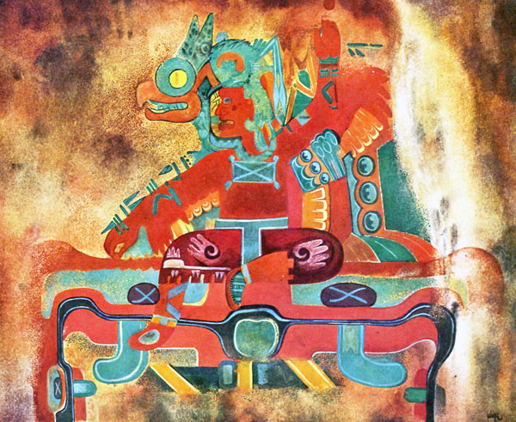



6) Ahuinahuac (99 ° 32 ' W, 17 ° 56 ' N) was excavated from 1989-1990. 7 Mezcala figures were discovered buried in embankments. The site is two km downstream from the modern village of San Juan Tetelcingo, municipality of Tepecoacuilco in the State of Guerrero. The site, which overlooks the Balsas River is on a steep slope with a vertical drop of 15 m. It has architectural and artefactual remains over most of its surface of approximately 200 m by 200 m. Surface samples show two different occupations, one in the north and the other in the south.

Two trenches, one along the axis of the terrace and the other perpendicular to it, uncovered six of the seven Mezcala objects within a two-meter radius at Operation 6. These anthropomorphic pieces consist of four masks and two figures a greenish gray serpentine marbled with white.  Five pieces: the four masks (3D4, 6D2, 6B1 and 4F1) and the figurine (4G2) form a very homogeneous ensemble. The anthropomorphic profile figurine (4B1) was distinguished from the others because of its uniqueness. The element to th right of the anthropomorphic profile is a monkey tail that signifies a shape shifting capability of the individual profiled who is a shaman. Therefore, this is a shamanic amulet or charm pendant.

 

Fig. 5. Detail of the Ahuinahuac Site, after http://www.samildan-art.com.



 

Fig. 9. a-f. Four Mexcala masks, two Mezcala figurines and one Mezcala anthropomorphic pendant with a monkey’s tail signifying a shamanic shape shift, after http://www.samildan-art.com.

Four Mexcala masks and two Mezcala figurines were excavated, at various strata, inside a thick embankment associated with the demolition of buildings and the redevelopment of the terrace. These stone offerings were probably deposited to highlight significant changes in the historical development of the site. The seventh Mezcala piece, 5B2, is an anthropomorphic silhouette pendant, which was discovered in an embankment during Operation 5. It may be an amulet of an ancestral figure as it is unique. It was misidentified in the site report as being an animal pendant.

Ahuinahuac is important because it is the only controlled Mezcala excavation that allows some level of relative dating. It is located on the right bank of the Balsas River, on alluvial terraces with stone figurines deliberately buried in an embankment that served as the basis for the construction of new housing structures. While is difficult to know the precise motive of this burial gesture, these offerings were deposited probably during a consecration of the new housing construction.

**References:**

Alcina Franch, J., 1961. — « Pequefias esculturas antropomorfas de Guerrero (Méjico) ».Revista de Indias 84, 295-350, Madrid.

Ángulo, J., 1966. — «Una ofrenda en el Templo Mayor de Tenochtitlan ». Boletin del

I.N.A.H. 26, 1-6, Mexico.

Batres, L., 1902. — Exploraciones arqueolôgicas en la calle de las Escalerillas. Ano de 1900.

Mexico, Tipografia y Litográfica La Europa.

Borbolla, D. F., Rubín de la., 1964. — « Escultura precolombina de Guerrero ». Dans

Escultura precolombina de Guerrero, D.F.R. de la Borbolla éd., 5-25, Mexico, UNAM.

Cabrera Castro, R., 1986. — « El proyecto arqueológico « Cocula ». Resultados

générales». Arqueologia y Etnohistoria del Estado de Guerrero, 173-200, INAH &

Gobierno del Estado de Guerrero.

Caso, A., 1965. — « Lapidary work, Goldwork, and Copperwork from Oaxaca ». Handbook

of Middle American Indians, Vol. 3, 2e partie, 896-930, sous la direction de G.R. Willey

Contreras, E., 1979. — « Una ofrenda en los restos del Templo Mayor de Tenochtilan ».Dans Trabajos arqueolôgicos en el centro de la ciudad de Mexico, E. Matos Moctezuma éd., 199-204, Mexico, INAH.

Covarrubias, Miguel. 1948. “Tipología de la industria de piedra tallada y pulida de la cuenca del río Mezcala”, en *El occidente de México. IV Mesa Redonda de la Sociedad Mexicana de Antropología, México*, Sociedad Mexicana de Antropología, pp. 86-90.

Covarrubias, Miguel, William Spratling, André Emmerich. 1956. *Mezcala, Ancient Mexican Sculpture*. Andre Emmerich Gallery.

Covarrubias, Miguel. 1966. *Indian art of Mexico and Central America*. New York: A. A. Knopf.

Easby, E. K. & J. F. Scott, 1970. — Before Cortěs : Sculpture of Middle America, NY,

The Metropolitan Museum of Art.

Gay, С. Т., 1968. — « Mezcala Stone Sculpture : The Human Figure » Studies Number Five New York: The Museum of Primitive Art.

Gay, Carlo, Frances Pratt; Gaston Burnand. 1992. *Mezcala-Ancient Stone Sculpture from Guerrero Mexico.* Geneva, Switzerland; Balsas Publications.

Gonzalez, С J., 1987. — « Mezcala Style Anthropomorphic Artifacts in the Templo

Mayor». Dans The Aztec Templo Mayor, sous la direction de E. Hill Boone, 145-160,

Dumbarton Oaks Research Library and Collection, Washington D. C.

Gonzalez, C. J. & B. Olmedo Vera, 1986. — « Piezas antropomorfas de estilo Mezcala

en el Templo Mayor ». Arqueologia y Ethnohistoria del Estado de Guerrero, 255-263,

INAH & Gobierno del Estado de Guerrero.

Griffin, Gillett G. 1972. “Xochipala: The earliest great art style in Mexico,” Proceedings of the American Philosophical Society 116 (4): 301–309.

Hansen, Richard. 2014. The Origins & Collapse of the Preclassic Maya in the Mirador Basin, Guatemala: Cultural & Natural Dynamics in the Cradle of the Maya Civilization. Library of Congress. Transcript: http://www.loc.gov/today/cyberlc/transcripts/2014/140402gmd1900.txt

Malmström, Vincent H. 1997. *Cycles of the Sun, Mysteries of the Moon: The Calendar in Mesoamerican Civilization.* Austin: University of Texas Press.

Malmström, Vincent H. 1998. “A Survey of Teopantecuanitlán, Guerrero, Mexico: the results of a field investigation undertaken with Dartmouth College Faculty Research Funds during the Winter Term, 1998.” Report submitted to Dr. J. Bharucha, Associate Dean of Social Sciences, Dartmouth College.

Martin A., Emelina, 1976. — « Figuras-hacha de la cultura Guerrero y su posible

función ». Cuadernos Prehispánicos, ano 4, 4, 69-91, Valladolid, Espagne.

Martinez Donjuan, G., 1986. — « Teopantecuanitlan, Guerrero». Arqueologia y

Etnohistoria del Estado de Guerrero, 55-82, INAH & Gobierno del Estado de Guerrero.

Morales Aguilar, Carlos, Richard D. Hansen, Abel Morales López y Wayne K. Howell

2008. « Nuevas perspectivas en los modelos de asentamiento Maya durante el Preclásico en las Tierras Bajas: Los sitios de Nakbe y El Mirador, Petén. En XXI Simposio de Investigaciones Arqueológicas en Guatemala, 2007 » (editado por J. P. Laporte, B. Arroyo y H. Mejía), pp.198-213. Museo Nacional de Arqueología y Etnología, Guatemala (versión digital).

Niven, William. 1897. “Omitlán, A Prehistoric City in Mexico,” Journal of the American Geographical Society of New York, 29(2): 217–222.

Noguera, E., 1961. — « Ultimos descubrimientos en Xochicalco ». RMEA 17, 33-37,

Mexico.

Paradis, L. I., n.d., «Teotihuacan and Precolumbian Guerrero». Paper presented at the

Society for American Archaeology Meeting in Toronto, Canada, May 1987.

Paradis Louise Iseut, Belanger Сhristian, Raby D., Ross B. 1990. “The Mezcala style discovered in context in Guerrero (Mexico)” *Journal of the Society of Americanists*, 76: 199-212.

Paradis, Louise Iseut. 1981, ‘Guerrero and the Olmec’ In The Olmec and their Neighbors, Edited by: Stirling, Matthew Williams, Coe, Michael D., and Grove, David C., pp: 195–208, (Washington D.C.: Dumbarton Oaks.

Paradis, L. I. & C. Bélanger, 1986. — « Le projet Mezcala et le Guerrero Précolombien ».

*Recherches Amérindiennes au Québec* XVI (2 + 3), 103-112, Montréal.

Reyna Robles, Rosa María. 2003. *La Organera-Xochipala: Un sitio del Epiclásico en la Región Mezcala de Guerrero.* Mexico City, Mexico: Instituto Nacional de Antropología e Historia.

Reyna Robles, Rosa María. 2006. "La Organera-Xochipala, Guerrero," *Arqueología Mexicana*, XIV: 82.

Reyna Robles, Rosa Ma., La Organera-Xochipala, un sitio del Epiclásico en la región Mezcala de Guerrero, México, INAH (Científica, 453), 2003.

Reyna Robles, Rosa Ma., La cultura arqueológica Mezcala, México, INAH (Científica, 487), 2006.

Reyna Robles, Rosa Ma., “La relación Teotihuacán-Guerrero: datos e interpretación”, ponencia presentada en el Simposio Teotihuacán y el Occidente. Interacción, Símbolos de Poder y Procesos Políticos, 29 de noviembre de 2012.

Reyna Robles, Rosa Ma., “Cálculos y movimientos de población: el Clásico en Guerrero”, ponencia presentada en el Seminario sobre el Norte de Guerrero, México, Coordinación Nacional de Antropología-INAH, 16 de abril de 2013a.

Reyna Robles, Rosa Ma., “Economía y rutas de intercambio”, ponencia presentada en el Seminario sobre el Norte de Guerrero, Coordinación Nacional de Antropología-INAH, 18 de junio de 2013b.

Reyna Robles, Rosa Ma. y Elizabeth Galeana, “El Clásico en Guerrero: ¿interacción o movimientos sociales?”, ponencia presentada en la IV Mesa Redonda El Conocimiento Antropológico e Histórico sobre Guerrero: Movimientos Sociales, Causas y Consecuencias, Taxco, 18-21 de agosto de 2010.

Reyna Robles, Rosa Ma. y Lauro González Quintero, Rescate arqueológico de un espacio funerario de época olmeca en Chilpancingo, Guerrero, México, INAH (Científica, 382), 1998.

Reyna Robles, Rosa Ma. y Omar Silis, “Arqueología en el área de Coahuayutla”, ponencia presentada en la VI Mesa Redonda El Conocimiento Antropológico e Histórico sobre Guerrero: Avances en su Investigación y su Relación con las Regiones Vecinas, Taxco, 26-29 de agosto de 2014.

Rodriguez Betancourt, F., 1986. — « Desarrollo cultural en la region de Mezcala-Teteladel Rio ». Arqueologia y Etnohistoria del Estado de Guerrero, 155-170, INAH & Gobierno del Estado de Guerrero.

Rubín de la Borbolla, Daniel Fernando. 1964. *Escultura precolombina de Guerrero.* Mexico City, Mexico: México Universidad Nacional Autónoma de México, Dirección General de Difusión Cultural, Museo de Ciencias y Arte.

Saenz, С. А., 1961. — « Très estelas en Xochicalco ». RMEA, 17, 39-65, Mexico.

Schmidt, Paul, Arqueología de Xochipala, Guerrero, México, IIA-UNAM, 1990.

Serra Puche, Mari Carmen, Xochitécatl, México, Gobierno del Estado de Tlaxcala, 1998.

Saenz, С. А., 1961. — « Très estelas en Xochicalco ». RMEA, 17, 39-65, Mexico.

Serra, M. C, 1973. — « Intento de seriación en esculturas de Guerrero : cronologia delestilo Mezcala ». XIII Mesa redonda (Xalapa, Veracruz), Sociedad Mexičana de

Antropologia, tomo 2 : 337-348, Mexico.

Sharer, Robert J.; Loa P. Traxler. 2006. *The Ancient Maya*. 6th ed. Stanford, CA: Stanford University Press.

Spratling, W., 1964. — « Notes on the Precolumbian Sculpture of Guerrero ». Escultura precolombina de Guerrero, UNAM, 27-37, Mexico.

Šprajc, Ivan, Carlos Morales-Aguilar, and Richard D. Hansen (2009). [Early Maya Astronomy and Urban Planning at El Mirador, Peten, Guatemala](http://www.drustvo-antropologov.si/AN/PDF/2009_3/Anthropological_Notebooks_XV_3_Sprajc.pdf). *Anthropological Notebooks* 15 (3): 79−101.

Suyuc Ley, Edgar; Hansen, Richard D. ["El complejo piramidal La Danta: ejemplo del auge en El Mirador"](http://www.mesoweb.com/publications/MMS/14_Suyuc-Hansen.pdf) (PDF).

Szymanski, Jan (2013). [*"Between Death and Divinity. Rethinking the Significance of Triadic Groups in Ancient Maya Culture"*](https://depotuw.ceon.pl/bitstream/handle/item/358/Between%20Death%20and%20Divinity.pdf?sequence=1) ([*PDF*](https://en.wikipedia.org/wiki/PDF)). PhD Dissertation. Warsaw, Poland: [*University of Warsaw*](https://en.wikipedia.org/wiki/University_of_Warsaw)*. Retrieved 2014-01-13*.

Uzu, Charlotte. 2000. *Les figurines en terre cuite de la région Tepecoacuilco-Balsas Guerrero, Mexique*. [Montréal]: Université de Montréal.